**STOCK MARKET PREDICTION USING ML**

*A Course Project Report submitted to the*

# VNR VIGNANA JYOTHI INSTITUTE OF TECHNOLOGY HYDERABAD

*in partial fulfilment of the requirements for the award of the degree of*

**BACHELOR OF TECHNOLOGY**

IN

# COMPUTER SCIENCE & ENGINEERING

**Submitted by**

**B.Supreeth Reddy**   **21071A0507**

**B.Bala Karthikeya 21071A0510**

**K.Abhigna 21071A0525**

**M.Viswanathan Anand 21071A0538**

**Under the Guidance of**

**Mr. Ch.Sri Sumanth**



**VALLURUPALLI NAGESWARA RAO VIGNANA JYOTHI INSTITUTE OF ENGINEERING AND TECHNOLOGY**

An Autonomous Institute, NAAC Accredited with ‘A++’ Grade (CGPA: 3.73/4.0)

NBA Accredited for CE, EEE, ME, ECE, CSE, EIE, IT B.Tech. Programmes Approved by AICTE, New Delhi, Affiliated to JNTU-H, Recognised as “College with Potential for Excellence” by

UGC

VignanaJyothi Nagar, Pragathi Nagar, Nizampet (S.O), Hyderabad TS 500 090 India

**2023**

**VALLURUPALLI NAGESWARA RAO VIGNANA JYOTHI**

**INSTITUTE OF ENGINEERING AND TECHNOLOGY**

An Autonomous Institute, NAAC Accredited with ‘A++’ Grade (CGPA: 3.73/4.0)

NBA Accredited for CE, EEE, ME, ECE, CSE, EIE, IT B.Tech. Programmes

Approved by AICTE, New Delhi, Affiliated to JNTU-H, Recognised as “College with Potential for Excellence” by UGC

VignanaJyothi Nagar, Pragathi Nagar, Nizampet (S.O), Hyderabad TS 500 090 India



# CERTIFICATE

This is to certify that **B.Supreeth Reddy(21071A0507)**,**B.Bala Karthikeya (21071A0510)**, **K.Abhigna (21071A0525)** & **M.Viswanathan Anand (21071A0538)** have successfully completed their project work at **Computer Science & Engineering Department** of **Vallurupalli Nageswara Rao Vignana Jyothi Institute of**

**Engineering and Technology,** Hyderabad entitled **“STOCK MARKET**

**PREDICTION USING ML”** in partial fulfilment of the requirements for the award of **B.Tech** during the academic year 2022-2023**.**

This work is carried out under my supervision and has not been submitted to any other University/ Institute for award of any degree/ diploma.

|  |  |
| --- | --- |
| **Mr. Ch Sri Sumanth** | **Dr. S Nagini** |
| **Assistant Professor** | **Associate Professor and HoD** |
| **CSE Department** | **CSE Department** |
| **VNRVJIET** | **VNRVJIET** |
| **Hyderabad** | **Hyderabad** |

**External Examiners**

## DECLARATION

This is to certify that the project work entitled **“STOCK MARKET PREDICTION USING ML”** submitted in VNR Vignana Jyothi Institute of Engineering & Technology in partial fulfilment of requirement for the award of Bachelor of Technology in Computer Science and Engineering is a bonafide report of the work carried out by us under the guidance and supervision of Mr. Ch Sri Sumanth, Assistant Professor, Department of CSE, VNRVJIET. To the best of our knowledge, this report has not been submitted in any form to any university or institution for the award of any degree or diploma.

Submission Dt:

|  |  |
| --- | --- |
| **B.Supreeth Reddy B.Bala Karthikeya**  **21071A0507 21071A0510**  **CSE 1 CSE 1**  **VNR VJIET VNR VJIET** | **K. Abhigna**  **21071A0525**  **CSE 1**  **VNR VJIET** |

**M.Viswanathan Anand**

**21071A0538**

**CSE 1**

**VNR VJIET**

## ACKNOWLEDGEMENT

An endeavour over a long period can be successful only with the advice and support of many well-wishers. We take this opportunity to express our gratitude and appreciation to all of them. We are indebted to our venerable principal **Dr. C. D. Naidu** for this unflinching devotion, which lead us to complete this project. The support, encouragement given by him and his motivation led us to complete this project. We wish to express our profound gratitude to **Dr. S. Nagini, Associate Professor** and **HOD CSE** Department**, VNR Vignana Jyothi Institute of Engineering and Technology** for their constant and dedicated service to brighten our carrier.

With a great pleasure we express our gratitude to the internal guide **Mr**. **Ch Sri Sumanth, Assistant Professor, CSE** for his timely help, constant guidance, cooperation, support and encouragement throughout this project. Finally, we wish to express our deep sense of gratitude and sincere thanks to our parents, friends and all our well-wishers who have technically and non-technically contributed for the successful completion of our course-based project.

## ABSTRACT

Stock markets help companies to raise capital.It helps generate personal wealth.Stock markets serve as an indicator of the state of the economy.It is a widely used source for people to invest money in companies with high growth potential. Traders in the stock market buy or sell shares on one or more of the stock exchanges that are part of the overall stock market.

Stock Price Prediction using machine learning helps you discover the future value of company stock and other financial assets traded on an exchange. The entire idea of predicting stock prices is to gain significant profits. Predicting how the stock market will perform is a hard task to do.

Stock market prediction and analysis are some of the most difficult jobs to complete. There are numerous causes for this, including market volatility and a variety of other dependent and independent variables that influence the value of a certain stock in the market. These variables make it extremely difficult for any stock market expert to anticipate the rise and fall of the market with great precision.

This project helps in analysis the trend of stock prices with minimum offset using machine learning.

## TABLE OF CONTENTS

|  |  |
| --- | --- |
| Details of content | Page # |
|  |  |
| Abstract | 9 |
| Table of contents | 11 |
| Introduction | 13 |
| Methodology | 14-15 |
| Implementation | 16-17 |
| Algorithm | 18 |
| Interface of Web Application | 19-21 |
| Conclusion | 22 |

## INTRODUCTION

Stock market can be something hard to guess, today we might see a price, check out the price of the same stock few minutes later, it will be a different story. We might often hear many investors saying that stock prices are so unpredictable and they have lost their money.

With help of right data and machine learning variations in stock prices can be predicted which can help a lot of investors by saving money and time and safeguard their investment.

Stock market prediction is a web application which is implemented by using machine learning to analyse stock prices .

The dataset which consists of details such as name of the stock , stock code ,opening price, closing price, high and low of price, volume of stock traded in a trading session over the past few years are considered.

Certain algorithms of ML are performed on dataset to convert the data into machine understandable language.

This project aims to predict stock trends to help the investors to decide whether to buy, sell or hold the stock by forecasting the price using previous data.

## METHODOLOGY

Modules used in this process are

* Yfinance - library for obtaining data from yahoo finance API

The Yahoo Finance API is a RESTful API that provides access to financial data. This data includes stock quotes, historical prices, and company information. The API is free to use and does not require an API key.

* Pandas-open-source Python library designed to deal with data analysis and data manipulation.

The main data structure in Pandas is a 2-dimensional table called **Data Frame**. To create a Data Frame, you can import data in several formats, such as *CSV*, *XLSX*, *JSON*, *SQL.*

With some lines of code, you can add, delete, or edit data in your rows/columns, check your set’s statistics, identify and handle missing entries, etc.

* Pandas_datareader - library for obtaining financial & economic data from online sources such as yahoo finance

This module is specifically designed to interface with some of the world's most popular financial data APIs, and import their data into an easily digestible pandas DataFrame

* Numpy-used for working with arrays

It also has functions for working in domain of linear algebra, fourier transform, and matrices. The array object in NumPy is called ndarray, it provides a lot of supporting functions that make working with ndarray very easy.

* Matplotlib - a comprehensive library for creating visualizations

Matplotlib is a cross-platform, data visualization and graphical plotting library for Python and its numerical extension NumPy. As such, it offers a viable open source alternative to MATLAB.

* Sklearn - contains tools for ML, including regression and statistical modeling

As a high-level library, it lets you define a predictive data model in just a few lines of code, and then use that model to fit your data. It’s versatile and integrates well with other Python libraries, such as [matplotlib for plotting**,**](https://www.activestate.com/resources/quick-reads/what-is-matplotlib-in-python-how-to-use-it-for-plotting/)[numpy for array vectorization**,**](https://www.activestate.com/resources/quick-reads/how-to-build-a-numpy-array/)and [pandas for dataframes**.**](https://www.activestate.com/resources/quick-reads/what-is-pandas-in-python-everything-you-need-to-know/)

* Streamlit-open source library for building and deploying ML and data science web applications

Streamlit allows you to re-use any Python code you have already written. This can save considerable amounts of time compared to non-Python based tools where all code to create visualizations needs to be re-written.

* Keras library provides a collection of functions for creating and training machine learning models.

keras.models is a module in keras library. We used ‘Sequential’ model which creates a simple linear stack of layers that define the model.’add’ method is used to add layers to the model.

**IMPLEMENTATION**

•

In sequential model and the data flows from one layer to another layer in the given

order until the data finally reaches the output layer.

•

We have trained each layer of our

model to extract features and pass them to next

layers to extract complex features

.

•

LSTM layer stands for Long Short

-

Term Memory, and it is a type of Recurrent

Neural Network (RNN) architecture used for processing sequential data like time

series or text.

•

LSTM unlike traditional RNN's have memory units which can store important

information for longer period this makes them ideal to handle sequential data which

have long term dependencies like time series data

.

•

This helps the network in classifying, proce

ssing and

make more accurate predictions

on time

series data.

This code creates a sequential model using the Keras library and adds several layers to

the model.

•

The first line creates an instance of the Sequential model.

•

The next line uses the model

.add method to add an LSTM layer with 50 units and the

ReLU

rectified linear unit)

(

activation function to the model.

•

The input_shape argument specifies the shape of the input data, where x_train.Shape

is the number of time steps and 1 is the

number of features. The return_sequences

argument is set to True, which means that the output from this layer will be passed to

the next layer in the sequence.

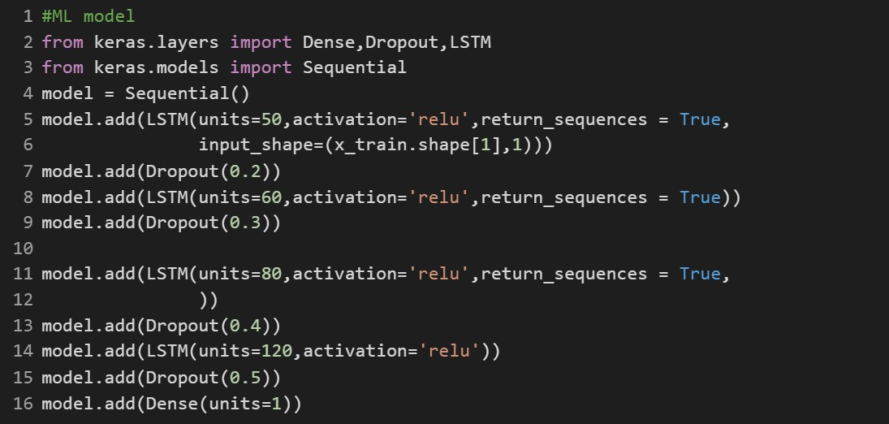

|  |  |
| --- | --- |
| •  •  •  •  • | The next line adds a Dropout layer with a rate of 0.2 to the model. This layer randomly drops out 20% of the neurons during training to prevent overfitting.    The next two lines repeat the process of adding an LSTM layer followed by a Dropout layer with increased units and dropout rate.    The last two lines add another LSTM layer with 120 units and a ReLU activation function and a Dropout layer with a rate of 0.5 to the model.    The final line adds a Dense layer with 1 unit to the model, which is used to make the final prediction.    In summary, this code creates a sequential model with several LSTM and Dropout layers that can be used for sequence modeling tasks.      17 |

## ALGORITHM

Here is a step-by-step algorithm for the code:

* Import the necessary libraries: yfinance, numpy, pandas,matplotlib, pandas_datareader, keras, and streamlit.

* Define the start and end dates for retrieving stock data: start='2012-01-01', end='2022-12-31'.

* Use streamlit to create a user interface and define a title for the app: st.title('Stock Trend Prediction').

* Ask the user to input a stock ticker using the text_input function and store the input in a variable user_input.

* Retrieve the stock data using yfinance.download and pass the user_input and the start and end dates as arguments. Store the data in a variable df.

* Use streamlit to display the summary statistics of the data using st.write(df.describe()).

* Plot the closing price of the stock over time using matplotlib and display it using st.pyplot.

* Plot the 100-day moving average of the closing price and display it using st.pyplot.

* Plot the 100-day and 200-day moving average of the closing price and display it using st.pyplot.

* Split the data into training and testing sets: data_training and data_testing.

* Scale the data using the MinMaxScaler function and store it in data_training_array.

* Load a pre-trained model using load_model and store it in a variable model.

* Prepare the testing data by using the last 100 days of the training data and appending the testing data to it. Scale the testing data using the MinMaxScaler function.
* Use a loop to split the testing data into windows of 100 days and store the windows in x_test. Store the next day's closing price in y_test.

* Use the model to predict the next day's closing price using model.predict and store the result in y_predicted.

* Scale y_predicted and y_test back to their original scale.

* Plot the original and predicted closing prices using matplotlib and display the plot using st.pyplot.

## INTERFACE OF WEB APPLICATION

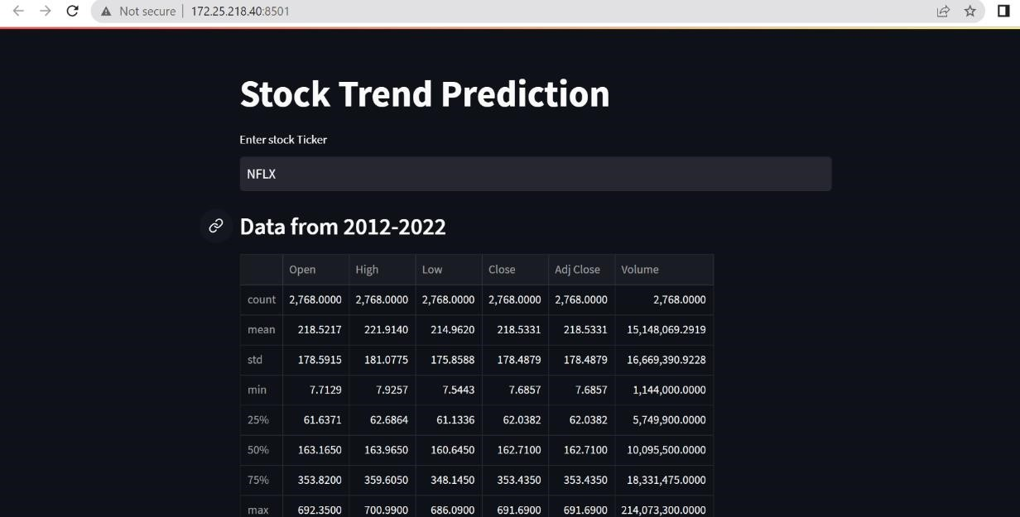

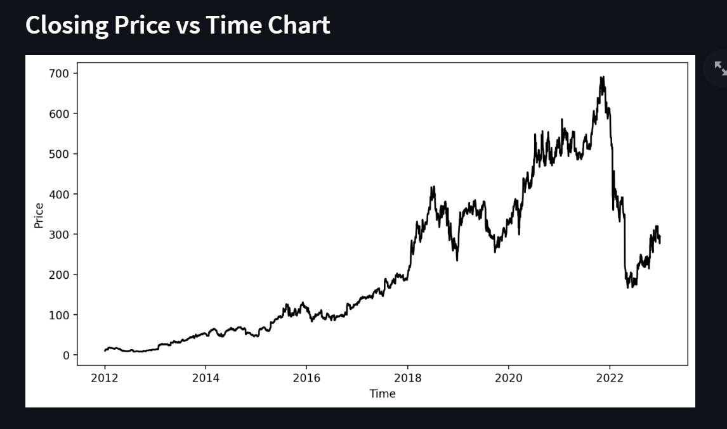

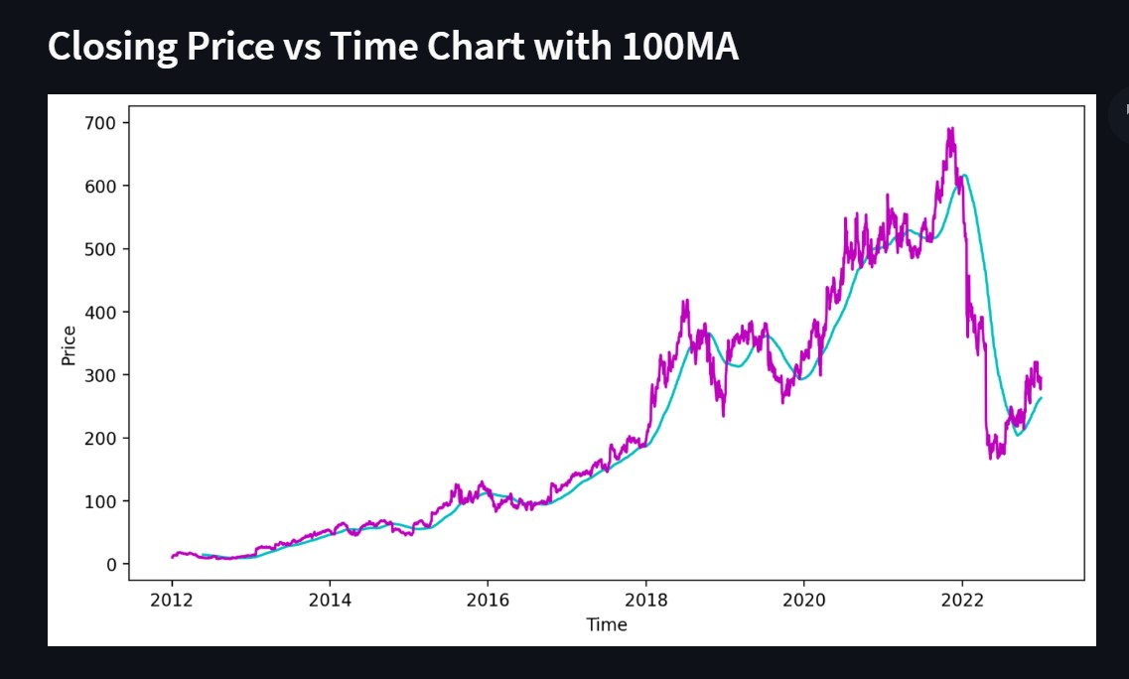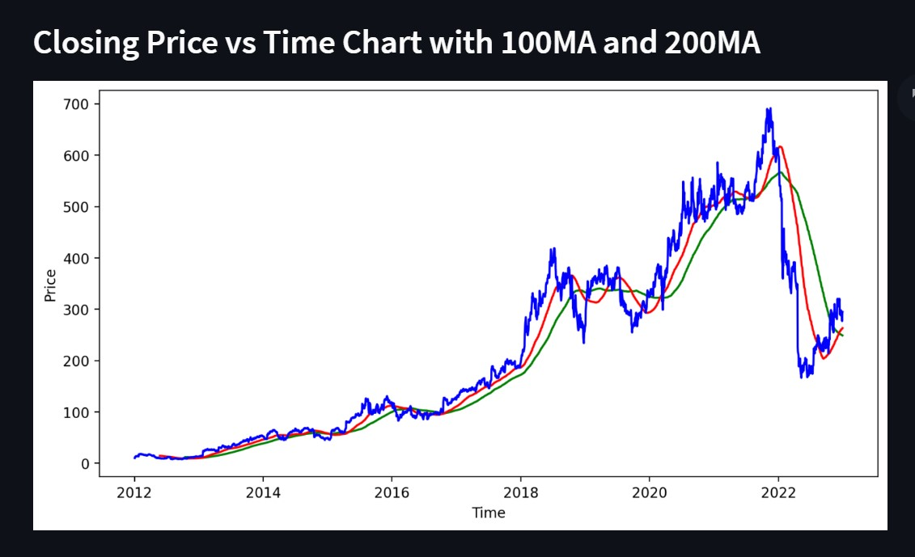

Final

result prediction vs original prices

The graph above demonstrates that the extremely basic single LSTM network model

created above detects some patterns. We may get a more accurate depiction of every

specific company’s stock value by fine

-

tuning many parameters and adding more

LSTM layers

to

the

model.

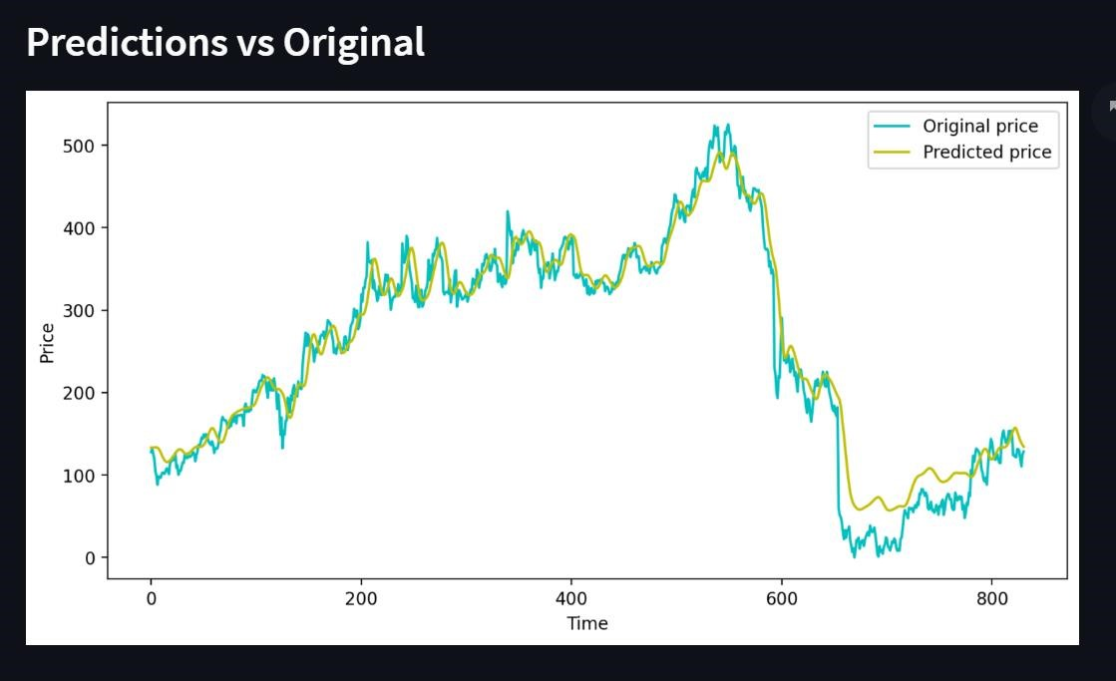

## CONCLUSION

Predicting the stock market was a time-consuming and laborious procedure a few years or even a decade ago. However, with the application of machine learning for stock market forecasts, the procedure has become much simpler. Machine learning not only saves time and resources but also outperforms people in terms of performance. it will always prefer to use a trained computer algorithm since it will advise you based only on facts, numbers, and data and will not factor in emotions or prejudice.